**M.D. ROBERTS MIDDLE SCHOOL Uniform Dress Code**

Uniform Dress will be strictly enforced throughout the 2018-2019 school year.

TOPS

* MAROON or WHITE tops only.
* Shirts with collars, (i.e. Polo style or button-down). Boys must wear shirts tucked into their pants.
* Solid color shirts adhering with the permissible colors listed above ONLY
* No striped, polka-dotted, patterned or non-collared shirts.
* ALL sweaters, jackets, vests, and sweatshirts, etc. must be solid WHITE, GRAY, BLACK or MAROON; with no other distinctive patterns or colors.
* Hoodies or jackets with a hood can be worn; however, you cannot wear the hood on your head inside the school. Outerwear worn throughout the school day is to be school colors. (Solid Maroon, White, Black or Gray).

BOTTOMS

* BLACK & KHAKI ONLY!
* Pants MUST be khaki styled or dress pants. Skirts, shorts, and “skorts” are also permitted.
* NO JEANS, SWEATPANTS, SKINNY PANTS, or JEGGINGS.
* NO SAGGING – Boys & girls must wear their pants up on their waists.
* Ladies: Appropriate lengths for skirts, shorts, and skorts must be no more than three inches above the knee. Leggings can be worn under skirts and reflect the school colors.
* Pants cannot be tucked into socks or shoes.

inside the school building. Hoodies worn throughout must be (Solid MAROON, WHITE or GRAY).

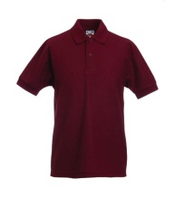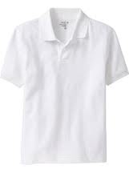

Accessories should not alter the appearance of the uniform dress code:

* Layer clothing within the parameters of the dress code-Solid MAROON, WHITE, BLACK & GRAY “only”
* No spikes or chains should be worn as accessories.
* No visible underwear
* No bandanas or head wraps
* No hats
* No T-shirts
* No Scarves

*Out of uniform” days will be announced to parents in advance.

RAM PRIDE

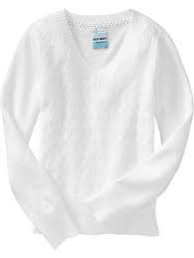

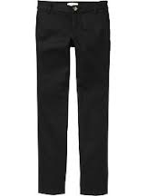

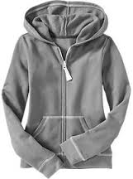

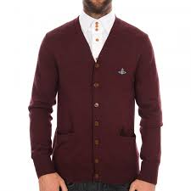

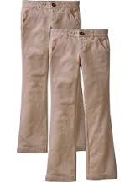

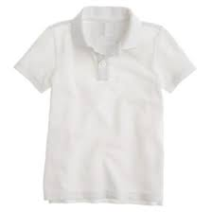

C:\Users\klee.CLAYTON\AppData\Local\Microsoft\Windows\Temporary Internet Files\Content.IE5\N6ZWZDH6\MC900162892[1].wmf